MCU-based Automated Water Management System

Prepared for: **James Michael Cañete,** Instructor  
Prepared by: **Holchi Henche B. Alin, Janluke Gabriel D. Ceballos, Josh B. Ratificar, Mohan Nuelle T. Francis, Rodjean E. Gere** (2:30-5:30 MON)

13 May 2024

Executive Summary

# Rationale

The proposed development is the deployment of an automated water level monitoring and distribution control system. The system tracks water circulation issues and monitors water level in Barangay Garing, Consolacion, in Cebu to address the challenge in water management. The current labor-intensive method of water level monitoring and distribution control is not only dangerous to the individual involved, but also provides unequal allocation of water. Through the use of ultrasonic sensors the water level will be continually monitored and displayed on an easily accessible LCD panel. This avoids the need for an individual to check the water level of the tank and endanger themselves in climbing to inspect the water tank. It also allows for the provision of real-time data on the availability of water, thus assisting the barangay to take timely actions based on fluctuations in the water supply. The application of servo motors to automate the distribution of water based on preset thresholds optimizes the use of resources, ensuring that every “purok” (a.k.a district or zone) has equal access to water while saving water during the periods of scarcity. This approach not only improves the operations but also helps in the development of sustainability, resilience and improvement of life to the people of Barangay Garing.

# Problem

The basis of the water management system in Barangay Garing, Consolacion, Cebu, is on manual water level checking and ineffective water supply distribution - exposing the community to risks and unequal allocations of water. A modernized, automated system is needed to ensure safety, water efficiency and equitable access to water for the people of barangay Garing.

# Goals and Objectives

The project’s goal is to develop a MCU-based water management system capable of measuring the water level, displaying the measured water level, and activating servo motors that control the distribution of water. Furthermore, the following objectives are to be met:

- study of data on ultrasonic sensors.

- utilization of the instruments such as the ultrasonic sensor, and servo motors.

- design & development of the software that will perform the task of reading and displaying data from the sensor.

- design & development of the software that will control servo motors based on water level and time.

- design & development of the electronic systems for the sensor, LCD display, and servo motors.

# Scope & Limitation

The project scope involves only the construction of the water level monitoring system and servo controller, the design and implementation of the electronic circuitry required for the ultrasonic sensor, and the development of the software running on the MCU to perform the task required.

The proposed design has the following limitations:

* System performance is dependent on the tank environment and sensor calibration.
* The puroks served by the system are limited by the capacity of the microcontroller and servo motors.
* Data is not logged in a memory system.

# Conceptual Framework

The following is the conceptual framework of the proposed project.

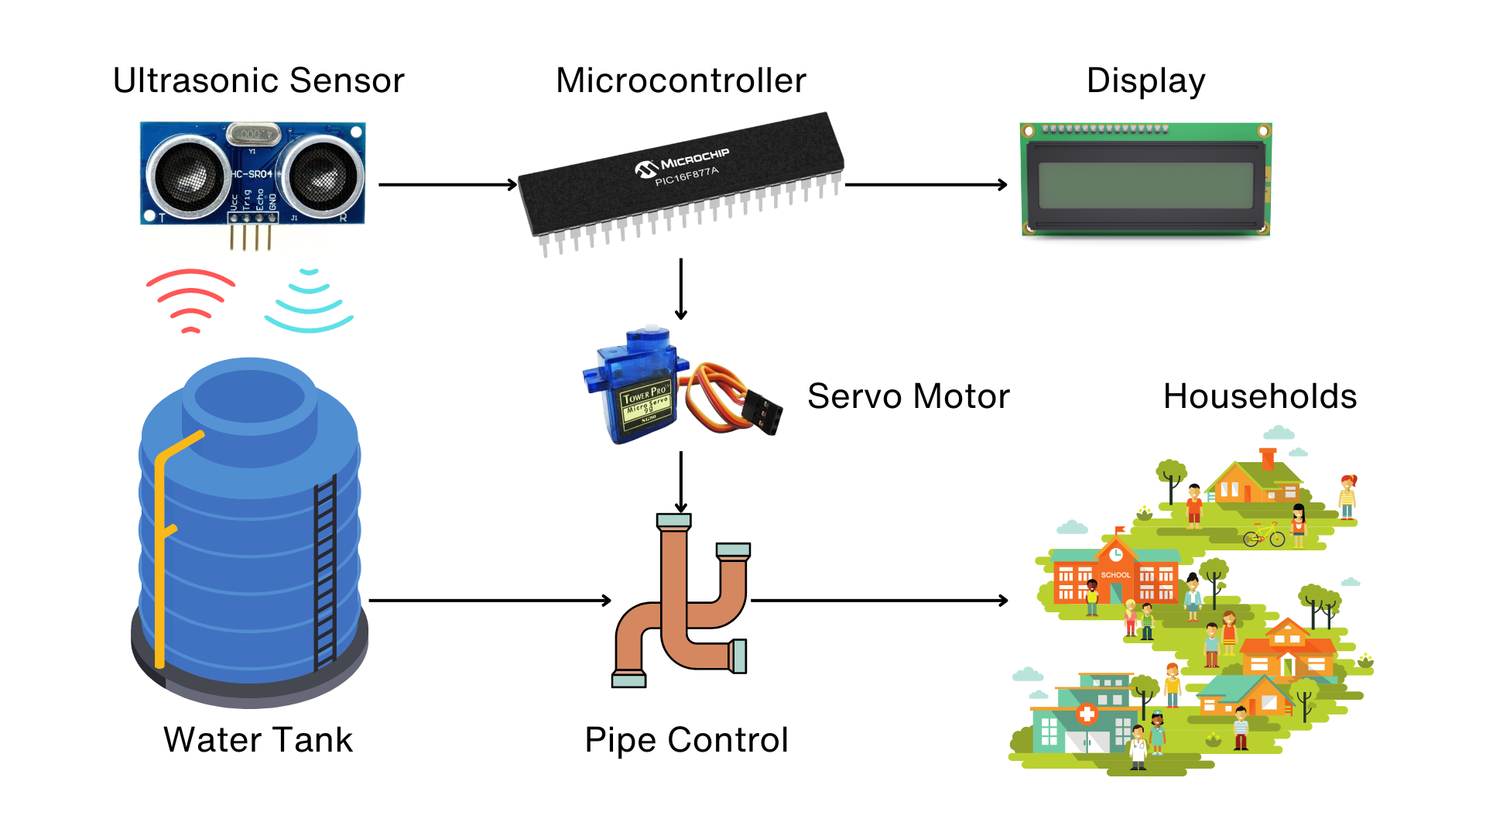

**Figure 1.0** - *Conceptual Framework*

They are interfaced to the microcontroller through their respective driver circuitry. The ultrasonic sensor, servo motor, and the liquid crystal display are directly interfaced to the MCU through the assigned GPIO ports. The ultrasonic sensor emits ultrasonic waves to gather depth data which is then used by the software. The data displayed are real-time and are constantly updated.

## System Block Diagram

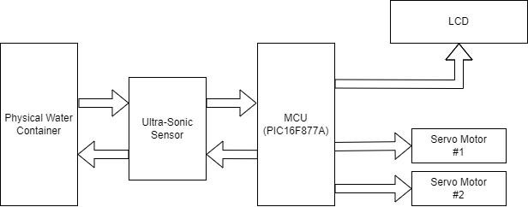

**Figure 2.0** - *System Block Diagram*

## Hardware Design

The system is controlled by the PIC16F877A microcontroller. The HC-SR04 ultrasonic sensor is mounted on a fixed stick above the water container. Using sensor data, the PIC calculates and displays the water level percentage (0% to 100%). It also controls two servo motors, each representing a pipe valve. When activated, the servo motors close the respective pipes, stopping the flow of water.

**Hardware Components:**

* 1x HC-SR04 UltraSonic Sensor
* 2x Servo Motors
* 1x LM044L LCD
* 1x 10k Potentiometer
* 2x 4MHz Crystal Oscillators
* 2x 20pF Capacitors
* 1x PIC16F877A Microcontroller
* 2x 2N2222 Transistor

## Software Design

The PIC16F877A microcontroller will facilitate communication with the ultrasonic sensor, interpreting its data to determine water depth. Utilizing the time taken for the ultrasonic signal to return, the system will gauge the water level through two key samples:

1. Total Time Taken with Empty Water Container: Establishes a baseline for time measurement when the container is devoid of water.
2. Total Time Taken with Half-Full Water Container: Provides a reference point for time measurement when the container is at a mid-point capacity.

Upon analysis of these samples, if the water level registers below or equal to 50%, a scheduler will be activated. The scheduler will systematically disable one servo motor at a time, allowing water flow through the enabled pipe. For demonstration purposes, the software will simulate scheduler activation at ten second intervals, although in practical applications, a scheduler would typically operate at longer intervals, such as every two hours. Conversely, if the water level surpasses 50%, the servo motors will deactivate, enabling simultaneous water flow through both pipes.

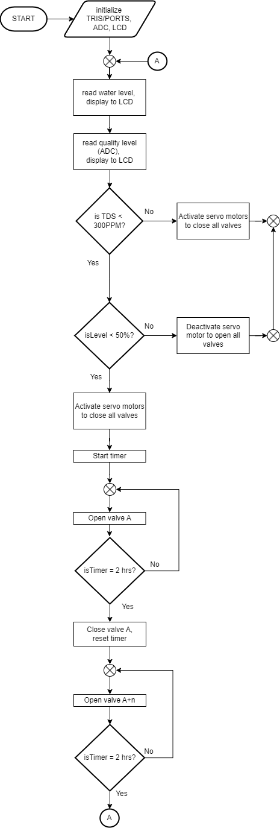

**Figure 3.0** - *System Design Flowchart*

# 

# Project Management

## Team Composition

**Josh Ratificar** (Team Leader/Hardware Lead) - Is responsible for the overall project development and progress. Employs the main hardware design and implementation methods.

**Mohan Nuelle Francis** (Member/Software Lead) - Assists the team leader and leads the software development which involves programming and interface design.

**Rodjean Gere** (Member/Hardware Design) - Responsible for the scheduler development.

**Holchi Henche Alin** (Member/Quality Assurance) - Responsible for integrating scheduler and sensor reading modules. Testing the integrated module.

**Janluke Gabriel Ceballos** (Member/ Documentation Lead) - Ensures documentation accuracy, completeness, and version control.

## Task Assignment

1. Development of the sensor device drivers (firmware) - Josh & Mohan
2. Design and prototyping of hardware components - Josh
3. Development of the task scheduler (firmware) - Rodjean
4. Programming and interface design for LCD display - Mohan
5. Integration of hardware and software components - Josh, Mohan, Rodjean
6. Integration testing and design validation - Holchi
7. Debugging and optimization - Holchi & Mohan
8. Coordination of project progress - Josh
9. Documentation and reporting - Janluke

## Project Timeline

| **Task** | May | | | | | |
| --- | --- | --- | --- | --- | --- | --- |
| 13 | 14 | 15 | 16 | 17 | 18 |
| Project Proposal Approval |  |  |  |  |  |  |
| Research on Ultrasonic Sensors |  |  |  |  |  |  |
| Design Circuit Diagram |  |  |  |  |  |  |
| Write the Code |  |  |  |  |  |  |
| Integration Testing |  |  |  |  |  |  |
| Debugging and Optimization |  |  |  |  |  |  |
| Submission of Project |  |  |  |  |  |  |

**Figure 4.0** - *Development of Timeline Chart*

## References

[1] Displaytech Ltd. “LCD Module Product Specification Product: 204A Series (20 Characters x 4 Lines)” , Displaytech 204A LCD Datasheet, April. 2009.   
Available: <https://www.seacomp.com/sites/default/files/datasheets/204A-Series-Displaytech-Spec.pdf>

[2] DFRobot “Gravity:AnalogTDSSensor/MeterForArduino SKU:SEN0244”, SEN0244 datasheet, (n.d). Available: <https://media.digikey.com/pdf/Data%20Sheets/DFRobot%20PDFs/SEN0244_Web.pdf>

[3] Handson Technology, “User Guide: Ultrasonic Sensor V2.0”, HC - SR04 datasheet, (n.d). Available:<https://www.handsontec.com/dataspecs/HC-SR04-Ultrasonic.pdf>

[3] Microchip “PIC16F87XA Data Sheet 28/40/44-Pin Enhanced Flash Microcontrollers”, PIC16F87XA datasheet, April. 2012.  
Available: <https://ww1.microchip.com/downloads/en/devicedoc/39582b.pdf>

[4] Tower Pro. “SG90 Datasheet”, SG90 datasheet, 2014.   
Available: <https://datasheetspdf.com/datasheet-pdf/791970/SG90.html>